Tugas 7_Rivan

**Codingan nya**

BasicFlatListData.js

import React, {Component} from 'react';

import {

    FlatList,

    StyleSheet,

    AppRegistry,

    Text,

    View,

    Image,

    TouchableOpacity,

    Modal,

    Button,

    Alert,

    TouchableHighlight,

    Platform

} from 'react-native';

import flatListData from '../data/flatListData';

*// import Rinci from '../data/rinci';*

import Judul from '../components/judul';

import Swipeout from 'react-native-swipeout';

import AddModal from './AddModal';

import EditModal from './EditModal';

class FlatListItem extends Component{

    constructor(*props*){

*super*(*props*);

        this.state={

            show:false,

            activeRowKey: null

        };

    }

    render(){

        const swipeSetting = {

            autoClose: true,

            onClose: (*secId*, *rowId*, *direction*) => {

                if (this.state.activeRowKey != null) {

                    this.setState({activeRowKey: null});

                }

            },

            onOpen: (*secId*, *rowId*, *direction*) => {

                this.setState({activeRowKey: this.props.item.key});

            },

            left: [{

                onPress: () => {

                    const deletingRow = this.state.activeRowKey;

                    Alert.alert(

                        'Alert',

                        'Sob yakin mau di hapus??',

                        [

                            { text: 'Yes', onPress: () => {

                                flatListData.splice(this.props.index, 1);

                                this.props.parentFlatList.refreshFlatList(deletingRow);

                            }},

                            {text: 'No', onPress: () => console.log('Cancel Pressed'), style: 'cancel'},

                        ],

                        {cancelable: true}

                    )

                },

                text: 'Delete', type: 'delete'

            }

            ],

            right: [{

                onPress: () => {

*// alert("update");*

                    this.props.parentFlatList.refs.editModal.showEditModal(flatListData[this.props.index],this);

                },

                text: 'Edit', type: 'primary'

            }

            ],

            rowId: this.props.index,

            sectionId: 1

        }

        return(

            <Swipeout {...swipeSetting}>

                <View *style*={{

                flex: 1,

                flexDirection: 'column'

            }}

            >

            <View *style*={{

                marginTop: 15,

                marginHorizontal: 15,

                flex: 1,

                flexDirection: 'row',

                backgroundColor: this.props.index % 2 == 0 ? '#2d98da' : '#0fb9b1',

                borderRadius: 15

*// backgroundColor: '#66CDAA'*

            }}>

            <Image

*source*={{uri:this.props.item.imageUrl}}

*style*={{

                width:100,

                height:100,

                margin:5,

                borderRadius: 80}}

            >

            </Image>

            <View *style*={{

                flex: 1,

                flexDirection: 'column',

                height: 100

            }}>

                <Text *style*={styles.flatListItem}>{this.props.item.name}</Text>

                <TouchableOpacity

*onPress*={() => {this.setState({show:true})}}>

                    <View>

                        <Text *style*={{

                            padding: 10,

                            margin: 5,

                            backgroundColor: '#fd9644',

                            borderRadius: 10,

                            color : 'white',

                            textAlign: 'center',

                            width: 150,

                        }}>

                            Selengkapnya

                        </Text>

                    </View>

                <Modal

*transparent*={true}

*visible*={this.state.show}

                    >

                        <View *style*={{backgroundColor: '#000000aa', flex: 1}}>

                            <View *style*={{backgroundColor: '#fd9644', margin:50, padding:30, borderRadius: 10, flex:1}}>

                                <Text *style*={{textAlign : "justify", fontSize: 15, color:'white'}}>{this.props.item.description}</Text>

                            <TouchableOpacity

*onPress*={() => {this.setState({show:false})}}>

                                <View>

                                    <Text *style*={{

                                        padding: 10,

                                        marginTop: 15,

                                        backgroundColor: 'red',

                                        borderRadius: 10,

                                        color : 'white',

                                        textAlign: 'center',

                                        width: 250,

                                    }}>

                                        Close

                                    </Text>

                                </View>

                            </TouchableOpacity>

                            </View>

                        </View>

                    </Modal>

                </TouchableOpacity>

            </View>

            </View>

            <View

*// style={{*

*//     borderBottomWidth: 1,*

*//     borderBottomColor: 'black'*

*// }}*

            >

            </View>

            </View>

            </Swipeout>

        )

    }

}

const styles = StyleSheet.create({

    flatListItem: {

        color: 'white',

        padding: 10,

        fontSize: 20

    }

});

export default class BasicFlatListData extends Component {

    constructor(*props*) {

*super*(*props*);

        this.state = ({

            deleteRowKey: null,

        });

        this._onPressAdd = this._onPressAdd.bind(this);

    }

    refreshFlatList = (*activeKey*) => {

        this.setState((*prevState*) => {

            return {

                deletedRowKey: *activeKey*

            };

        });

        this.refs.flatList.scrollToEnd();

    }

    _onPressAdd (){

*// alert("Berhasil lu Sob Menambah nya")*

        this.refs.addModal.showAddModal();

    }

    render(){

        return (

            <View *style*={{flex:1, marginTop: Platform.OS === 'android' ? 0 : 0}}>

                <Judul/>

                <View *style* ={{backgroundColor: '#fc5c65', height: 50,  flexDirection: 'row', justifyContent: 'flex-end', alignItems: 'center'}}>

                    <TouchableHighlight *style*={{marginRight: 10}} *underlayColor*='#fd9644' *onPress*={this._onPressAdd} >

                        <Image *style*={{width: 35, height:35}} *source*={require('../icons/iconadd.png')} />

                    </TouchableHighlight>

                </View>

                <FlatList

*ref*={"flatList"}

*data*={flatListData}

*renderItem*={({*item*, *index*}) => {

                    return (

                        <FlatListItem *item*={*item*} *index*={*index*} *parentFlatList*={this}>

                        </FlatListItem>

                    );

                }}

                >

                </FlatList>

                <AddModal *ref*={'addModal'} *parentFlatList*={this}>

                </AddModal>

                <EditModal *ref*={'editModal'} *parentFlatList*={this}>

                </EditModal>

            </View>

        )

    }

}

EditModal.js

import React, {Component} from 'react';

import {

    View,

    AppRegistry,

    FlatList,

    Text,

    StyleSheet,

    Image,

    Dimensions,

    Platform,

    TextInput

} from 'react-native';

import Modal from 'react-native-modalbox';

import Button from 'react-native-button';

import flatListData from '../data/flatListData';

var screen = Dimensions.get('window');

export default class AddModal extends Component{

    constructor(*props*){

*super*(*props*);

        this.state ={

            newFoodName : '',

            newFoodDescription: '',

            newFoodImage: '',

        };

    }

    showAddModal = () => {

        this.refs.myModal.open();

    }

    generateKey = (*numberOfCharacters*) => {

        return require('random-string')({length: *numberOfCharacters*});

    }

    render(){

        return (

            <Modal

*ref*={"myModal"}

*style*={{

                justifyContent: 'center',

                borderRadius: Platform.OS === 'android' ? 30 : 0,

                shadowRadius: 10,

                width: screen.width - 80,

                height: 280,

                backgroundColor: '#fc5c65'

            }}

*position*= 'center'

*backdrop*={true}

*onClosed*={() => [

*// alert('Modal Tertutup Sob')*

            ]}

            >

                <Text

*style*={{

                    textAlign: 'center',

                    color: 'white',

                    fontSize: 16,

                    fontWeight: 'bold'

                }}

                    >Ayo Tambahkan Makanan Sob</Text>

                    <TextInput

*style*={{

                        height: 40,

                        borderBottomColor: 'black',

                        marginHorizontal: 30,

                        marginTop: 20,

                        marginBottom: 10,

                        backgroundColor: 'white',

                        borderRadius: 10

                    }}

*onChangeText*={(*text*) => this.setState({newFoodName: *text*})}

*placeholder*= "Tambahkan makanan Baru"

*value*= {this.state.newFoodName}

                    />

                    <TextInput

*style*={{

                        height: 40,

                        borderBottomColor: 'black',

                        marginHorizontal: 30,

                        marginTop: 20,

                        marginBottom: 10,

                        backgroundColor: 'white',

                        borderRadius: 10

                    }}

*onChangeText*={(*text*) => this.setState({newFoodDescription: *text*})}

*placeholder*= "Tambahkan Deksripsi"

*value*= {this.state.newFoodDescription}

                    />

                    <TextInput

*style*={{

                        height: 40,

                        borderBottomColor: 'black',

                        marginHorizontal: 30,

                        marginTop: 20,

                        marginBottom: 10,

                        backgroundColor: 'white',

                        borderRadius: 10

                    }}

*onChangeText*={(*text*) => this.setState({newFoodImage: *text*})}

*placeholder*= "Tambahkan Gambar"

*value*= {this.state.newFoodImage}

                    />

                    <Button

*style*={{

                        fontSize: 18,

                        color: 'white'

                    }}

*containerStyle* = {{

                        marginTop: 8,

                        padding : 8,

                        height: 40,

                        borderRadius: 6,

                        marginLeft: 70,

                        marginRight: 70,

                        backgroundColor: '#2d98da'

                    }}

*onPress*={() => {

                        if(this.state.newFoodName.length == 0 || this.state.newFoodDescription.length == 0){

                            alert("Form Belum Di Input");

                            return;

                        }

                        const newKey = this.generateKey(24);

                        const newFood = {

                            key: newKey,

                            name: this.state.newFoodName,

                            imageUrl: this.state.newFoodImage,

                            description: this.state.newFoodDescription

                        };

                        flatListData.push(newFood);

                        this.props.parentFlatList.refreshFlatList(newKey);

                        this.refs.myModal.close();

                    }}

                    >

                        Save

                    </Button>

            </Modal>

        )

    }

}

AddModal.js

import React, {Component} from 'react';

import {

    View,

    AppRegistry,

    FlatList,

    Text,

    StyleSheet,

    Image,

    Dimensions,

    Platform,

    TextInput

} from 'react-native';

import Modal from 'react-native-modalbox';

import Button from 'react-native-button';

import flatListData from '../data/flatListData';

var screen = Dimensions.get('window');

export default class AddModal extends Component{

    constructor(*props*){

*super*(*props*);

        this.state ={

            newFoodName : '',

            newFoodDescription: '',

            newFoodImage: '',

        };

    }

    showAddModal = () => {

        this.refs.myModal.open();

    }

    generateKey = (*numberOfCharacters*) => {

        return require('random-string')({length: *numberOfCharacters*});

    }

    render(){

        return (

            <Modal

*ref*={"myModal"}

*style*={{

                justifyContent: 'center',

                borderRadius: Platform.OS === 'android' ? 30 : 0,

                shadowRadius: 10,

                width: screen.width - 80,

                height: 280,

                backgroundColor: '#fc5c65'

            }}

*position*= 'center'

*backdrop*={true}

*onClosed*={() => [

*// alert('Modal Tertutup Sob')*

            ]}

            >

                <Text

*style*={{

                    textAlign: 'center',

                    color: 'white',

                    fontSize: 16,

                    fontWeight: 'bold'

                }}

                    >Ayo Tambahkan Makanan Sob</Text>

                    <TextInput

*style*={{

                        height: 40,

                        borderBottomColor: 'black',

                        marginHorizontal: 30,

                        marginTop: 20,

                        marginBottom: 10,

                        backgroundColor: 'white',

                        borderRadius: 10

                    }}

*onChangeText*={(*text*) => this.setState({newFoodName: *text*})}

*placeholder*= "Tambahkan makanan Baru"

*value*= {this.state.newFoodName}

                    />

                    <TextInput

*style*={{

                        height: 40,

                        borderBottomColor: 'black',

                        marginHorizontal: 30,

                        marginTop: 20,

                        marginBottom: 10,

                        backgroundColor: 'white',

                        borderRadius: 10

                    }}

*onChangeText*={(*text*) => this.setState({newFoodDescription: *text*})}

*placeholder*= "Tambahkan Deksripsi"

*value*= {this.state.newFoodDescription}

                    />

                    <TextInput

*style*={{

                        height: 40,

                        borderBottomColor: 'black',

                        marginHorizontal: 30,

                        marginTop: 20,

                        marginBottom: 10,

                        backgroundColor: 'white',

                        borderRadius: 10

                    }}

*onChangeText*={(*text*) => this.setState({newFoodImage: *text*})}

*placeholder*= "Tambahkan Gambar"

*value*= {this.state.newFoodImage}

                    />

                    <Button

*style*={{

                        fontSize: 18,

                        color: 'white'

                    }}

*containerStyle* = {{

                        marginTop: 8,

                        padding : 8,

                        height: 40,

                        borderRadius: 6,

                        marginLeft: 70,

                        marginRight: 70,

                        backgroundColor: '#2d98da'

                    }}

*onPress*={() => {

                        if(this.state.newFoodName.length == 0 || this.state.newFoodDescription.length == 0){

                            alert("Form Belum Di Input");

                            return;

                        }

                        const newKey = this.generateKey(24);

                        const newFood = {

                            key: newKey,

                            name: this.state.newFoodName,

                            imageUrl: this.state.newFoodImage,

                            description: this.state.newFoodDescription

                        };

                        flatListData.push(newFood);

                        this.props.parentFlatList.refreshFlatList(newKey);

                        this.refs.myModal.close();

                    }}

                    >

                        Save

                    </Button>

            </Modal>

        )

    }

}

Di folder Tugas

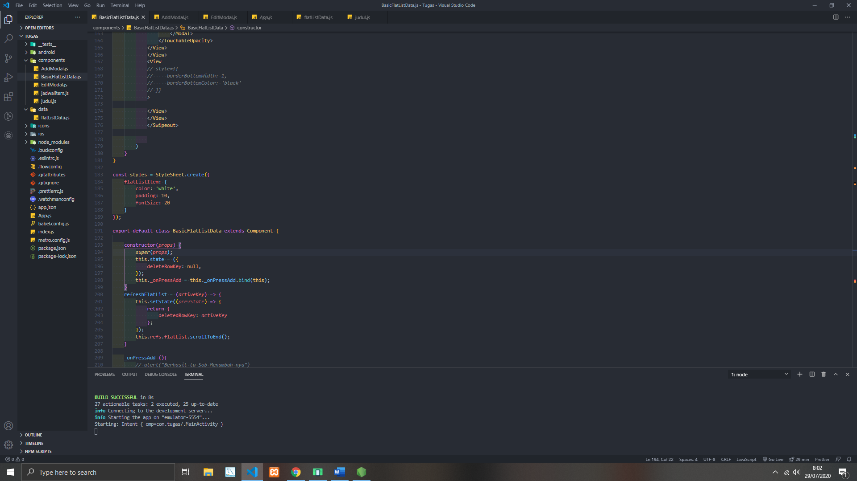

**Hasil Edit nya**

Sebelum di edit Nasi Goreng

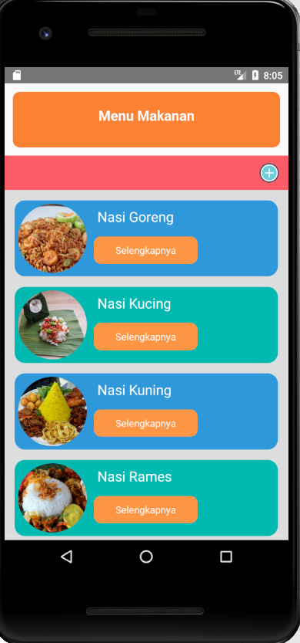

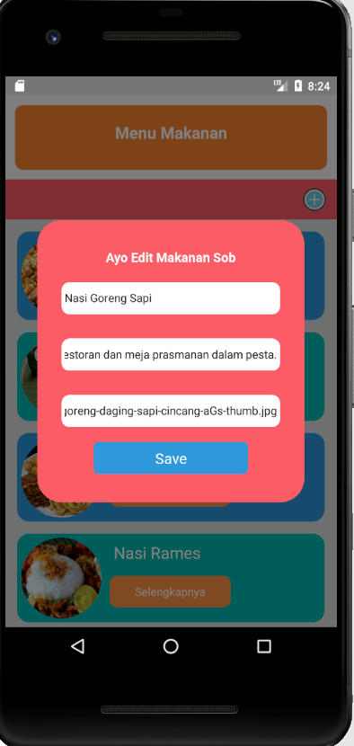

Sesudah di edit hasil nya Nasi Goreng Sapi

Dan gambar nya berubah

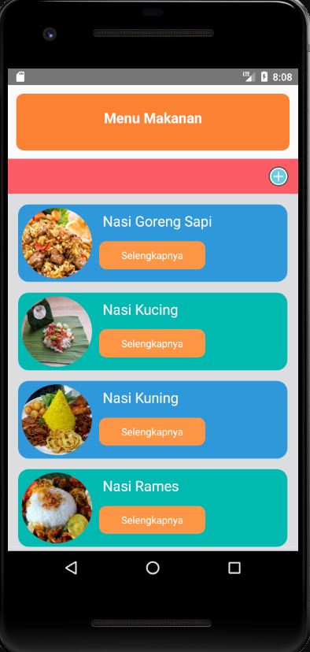

**Hasil Tambah Makanannya**

sebelum di tambah makanannya

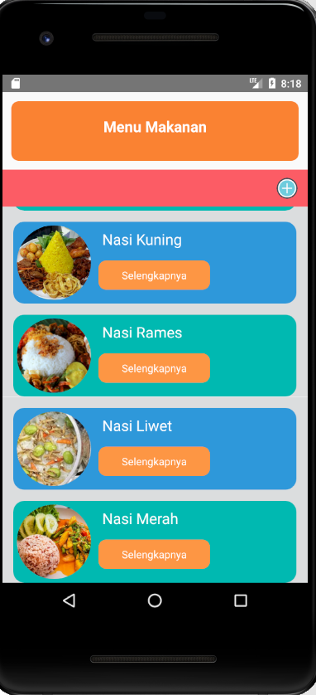

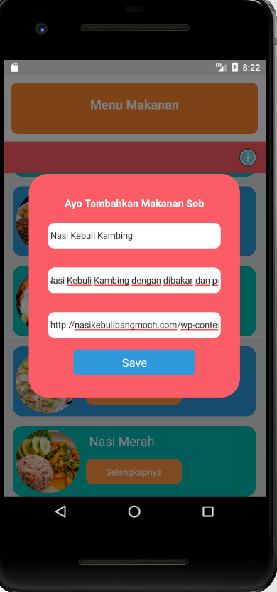

Sesudah Ditambahkan Makanannya

Muncul sama gambarnya

